**Threshold Recommendations based on Climate Normals for 1981-2010**

The following recommendations can be used as guidelines to decide the threshold value for various variables when choosing the *Extreme Weather Event Defined by User* definition option. The values below are from the 1981-2010 climate normals published by Environment and Climate Change Canada (ECCC).

**Number of days with daily temperature > or < x**

The numbers below are the climate normals for each month as well as the annual value:



The following values can also be used to define degree days:

**Number of days with maximum temperature > or < x**

The numbers below are the climate normals for each month as well as the annual value:



The following values can also be used to define extreme thresholds:

**Number of days with minimum temperature > or < x**

The numbers below are the climate normals for each month as well as the annual value:



The following values can also be used to define extreme thresholds:

**Occurrences where periods of >5 consecutive days are >x above/below normal temperature**

The numbers below are the climate normals for each month as well as the annual value:



**Number of days with humidex > x**

The following values can be used to define extreme thresholds:

**Number of days with wind chill < x**

The following values can be used to define extreme thresholds:

**Number of days with average relative humidity > or < x**

The numbers below are the climate normals for each month as well as the annual value:

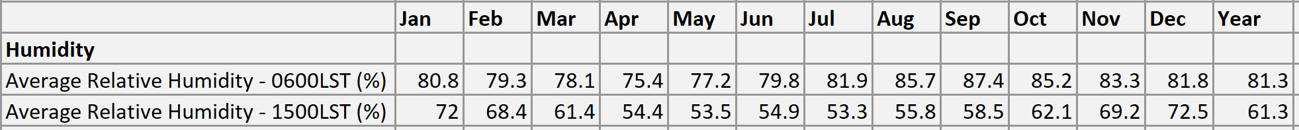

**Number of days with wind speed > or < x**

The numbers below are the climate normals for each month as well as the annual value:



The following values can also be used to define extreme thresholds:

**Number of days when daily precipitation > x**

The numbers below are the climate normals for each month as well as the annual value:



The following values can also be used to define extreme thresholds:

**Maximum number of consecutive days with daily precipitation amount > or < x**

The numbers below are the climate normals for each month as well as the annual value:



The following values can also be used to define extreme thresholds:

**Number of days with rainfall > or < x**

The numbers below are the climate normals for each month as well as the annual value:



The following values can also be used to define extreme thresholds:

**Number of days with snowfall > or < x**

The numbers below are the climate normals for each month as well as the annual value:



The following values can also be used to define extreme thresholds:

**Number of days with snow depth > or < x**

The numbers below are the climate normals for each month as well as the annual value:



The following values can also be used to define extreme thresholds:

**Number of days with surface air pressure > or < x**

The numbers below are the climate normals for each month as well as the annual value:



**Number of days with sea level pressure > or < x**

The numbers below are the climate normals for each month as well as the annual value:

